Project Design Phase
Solution Architecture
Date | 11 September
Project Name | Employee Raise Issue
Maximum Marks | 4 Marks

Solution Architecture:
Solution Architecture is the process of designing a structured ServiceNow solution that connects the employee’s issue-reporting needs with the required platform features. For the Employee Raise Issue – Record Producer & Service Portal Integration project, the architecture provides a clear view of how employees raise issues, how the information is captured, and how administrators manage the submitted requests.
Solution Architecture Diagram:
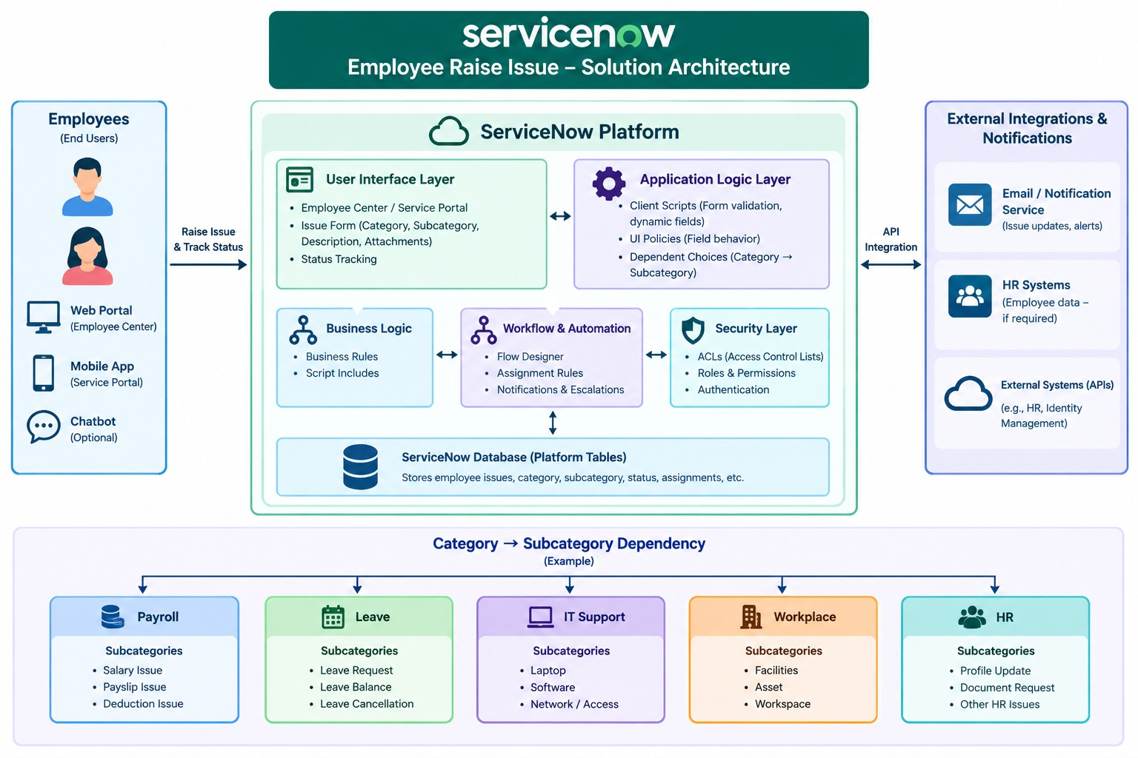

Goals of the Solution Architecture:
- Provide the right technology solution: Use ServiceNow Employee Center/Service Portal and a Record Producer to provide employees with a simple and centralized way to raise workplace or IT-related issues.
- Define the solution structure: The solution consists of an Employee Raise Issue table, Record Producer, variables, Category and dependent Subcategory, UI Policies, Client Scripts, and portal integration.
- Improve the employee experience: Employees can access the portal, enter the required information, select the appropriate category and subcategory, and submit their issue through a guided form.
- Ensure accurate information: Mandatory fields, UI Policies, and Client Scripts help validate information and control the form based on the project requirements.
- Centralize issue management: Submitted issues are stored in the Employee Raise Issue table, allowing administrators or support teams to review and manage employee concerns from one location.
- Define solution requirements: The architecture identifies the required tables, fields, Record Producer, portal components, validations, and user interaction flow needed to implement the application.
- Support future development: The solution can be extended with notifications, workflows, approvals, SLA tracking, reports, dashboards, and integrations with other organizational systems.

